Applicant: The name you choose here reflects who takes the medication you will list.

RX/Med: You should ONLY put the name of the drug and the frequency they take it here. Nothing else. (Make sure to spell it right… use GoodRx.) Example:

- Lisinopril, taken 1x daily.

Reason: It is always going to be Mild, controlled (enter condition here). Example:

- Mild, controlled High Blood Pressure.

Doctor: I recommend putting PCP in front of the doctor's name. Make sure to include this doctor’s information in your V-call notes. Example:

- PCP: Dr. Patel

Condition: This is where you copy and paste the condition from the “UW CHEAT SHEET (Application)” guide. Example:
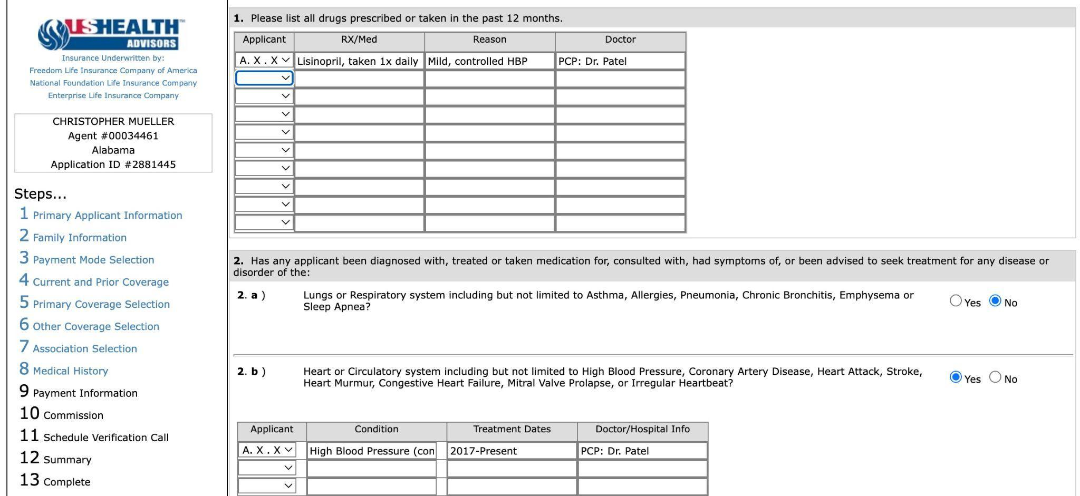
- High Blood Pressure (controlled by Rx, longer than 12 months, no hospitalization, no other risk factor present, no change of dosage in last 12 months, height and weight within guidelines, non-smoker)

Treatment Date: Year they started taking the medication to present. Never list over 7 years. Example:

- 2017-present.

